**Q1: Simple Pointer Example Program In C++**

#include<iostream>

using namespace std;

int main(){

int i = 10;

int *Ptr;

Ptr = &i;

cout << "\nValue Of i :" << i;

cout << "\nAddress Of i :" << i;

cout << "\nValue Of Ptr :" << Ptr;

cout << "\nAddress Of Ptr :" << &Ptr;

cout << "\nPtr's Pointer Value:" << *Ptr;

cout << "\nPtr Equal to &i :" << *(&i);

return 0;

}

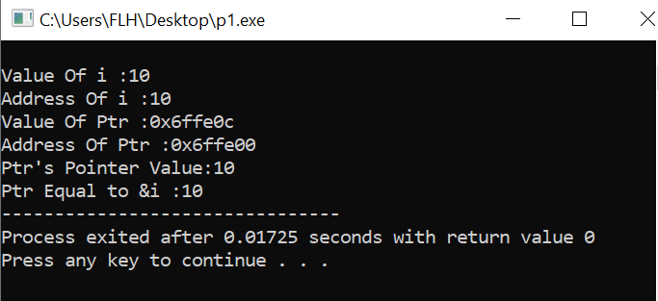

**Q2: Simple Program for Print address of Variable Using Pointer in C++**

#include <iostream>

#include<conio.h>

using namespace std;

int main() {

int a;

int *pt;

cout << "C++ Pointer Example Program : Print Pointer Address\n";

a = 10;

pt = &a;

cout << "\n[a ]:Value of A = " << a;

cout << "\n[*pt]:Value of A = " << *pt;

cout << "\n[&a ]:Address of A = " << &a;

cout << "\n[pt ]:Address of A = " << pt;

cout << "\n[&pt]:Address of pt = " << &pt;

cout << "\n[pt ]:Value of pt = " << pt;

return 0;

}

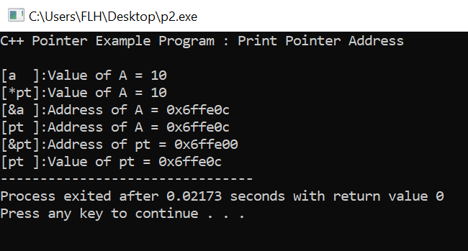

**Q3: Pointer Simple Example Program with Reference operator (&) and Dereference operator (*)**

#include <iostream>

#include<conio.h>

using namespace std;

int main() {

//Pointer Variable Declaration for Integer Data Type

int* pt;

int var;

cout << "C++ Pointer Example for Reference operator (&) and Dereference operator (*)\n";

var = 1;

cout << "Address of var :" << &var << "\n";

cout << "Value of var :" << var << "\n\n";

//& takes the address of var , Here now pt == &var, so *pt == var

pt = &var;

cout << "Address of Pointer pt :" << pt << "\n";

cout << "Content of Pointer pt :" << *pt << "\n\n";

var = 2;

cout << "Address of Pointer pt :" << pt << "\n";

cout << "Content of Pointer pt :" << *pt << "\n\n";

//Assign Values using dereference operator

*pt = 3;

cout << "Address of var :" << &var << "\n";

cout << "Value of var :" << var << "\n\n";

getch();

return 0;

}

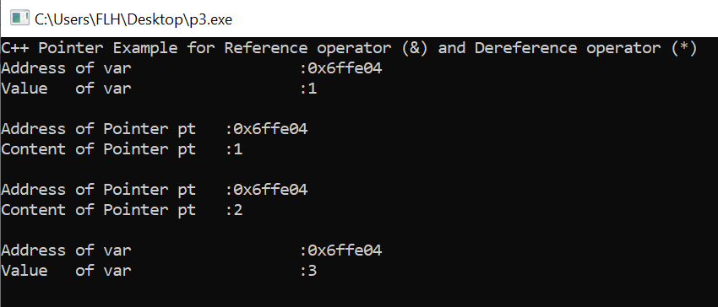

**Q4: Simple Example Program for Swap Numbers Using Pointers In C++**

#include <iostream>

#include<conio.h>

using namespace std;

// Declare Swap Function Using Pointer

void swap_numbers(int *value1, int *value2) {

int temp;

temp = *value1;

*value1 = *value2;

*value2 = temp;

}

int main() {

// Declare Variables

int number1, number2;

cout << "Simple Example Program for Swap Numbers Using Pointers In C++\n";

// Read User Input

cout << "Enter value of Swap Number # 1: ";

cin>>number1;

cout << "Enter value of Swap Number # 2: ";

cin>>number2;

//Print Values before Swapping

cout << "Before Swapping : Number # 1=" << number1 << ", Number # 2=" << number2 << "\n";

//Call Swap Function By Passing Reference

swap_numbers(&number1, &number2);

//Print Values after Swapping

cout << "After Swapping : Number # 1=" << number1 << ", Number # 2=" << number2 << "\n";

getch();

return 0;

}

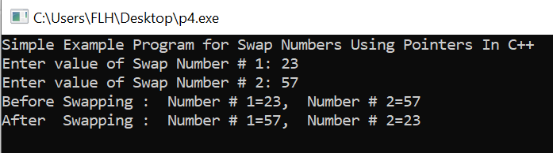

**Q5: Print size of different types Using Pointer in C++**

#include <iostream>

#include<conio.h>

using namespace std;

int main() {

// Declare Variables

int a = 10;

int *pa = &a;

char b = 'x';

char *pb = &b;

float c = 10.01;

float *pc = &c;

double d = 10.01;

double *pd = &d;

long e = 10.01;

long *pe = &e;

cout << "Pointer C++ Example Program : Print Size of Different types Using sizeof\n";

cout << "\n[sizeof(a) ]: = " << sizeof (a);

cout << "\n[sizeof(*pa) ]: = " << sizeof (*pa);

cout << "\n[sizeof(b) ]: = " << sizeof (b);

cout << "\n[sizeof(*pb) ]: = " << sizeof (*pb);

cout << "\n[sizeof(c) ]: = " << sizeof (c);

cout << "\n[sizeof(*pc) ]: = " << sizeof (*pc);

cout << "\n[sizeof(d) ]: = " << sizeof (d);

cout << "\n[sizeof(*pd) ]: = " << sizeof (*pd);

cout << "\n[sizeof(e) ]: = " << sizeof (e);

cout << "\n[sizeof(*pe) ]: = " << sizeof (*pe);

return 0;

}

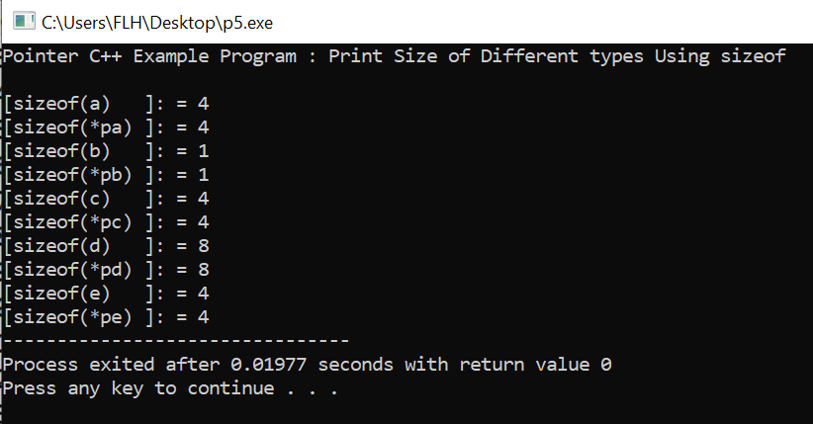

**Q6: Simple Program for Add Two Numbers Using Pointer in C++**

#include <iostream>

#include<conio.h>

using namespace std;

int main() {

int *p1, *p2;

int num1, num2, sum;

cout << "Pointer Example C++ Program : Add Two Numbers \n";

cout << "\nEnter Two Numbers for Sum : \n";

cin>>num1;

cin>>num2;

p1 = &num1;

p2 = &num2;

sum = *p1 + *p2;

cout << "Sum of Two Numbers : " << sum;

getch();

return 0;

}

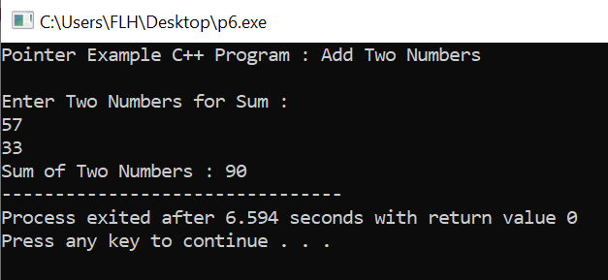

**Q7: Simple Program for Increment and Decrement Integer Using Pointer in C++**

#include <iostream>

#include<conio.h>

using namespace std;

int main() {

int a;

int *pt;

cout << "Pointer Example C++ Program : Increment and Decrement Integer\n";

a = 10;

pt = &a;

(*pt)++; //Post Increment

cout << "\n[a ]:Increment Value of A = " << a;

++(*pt); //Pre Increment

cout << "\n[a ]:Increment Value of A = " << a;

(*pt)--; //Post Decrement

cout << "\n[a ]:Decrement Value of A = " << a;

--(*pt); //Pre Decrement

cout << "\n[a ]:Decrement Value of A = " << a;

getch();

return 0;

}

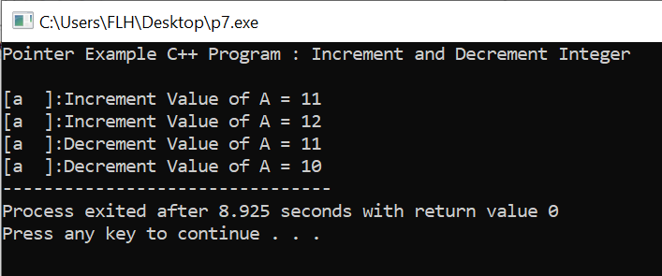

**Q8: Simple Program for Find a difference between two Numbers Using Pointer in C++**

#include <iostream>

#include<conio.h>

using namespace std;

int main() {

// Declare Variables

int *p1, *p2;

int num1, num2, diff;

cout << "Pointer Example C++ Program : Find a difference between two Numbers \n";

cout << "\nEnter Two Numbers for Find a Difference : \n";

cin>>num1;

cin>>num2;

p1 = &num1;

p2 = &num2;

diff = *p1 - *p2;

cout << "Difference :" << diff;

getch();

return 0;

}

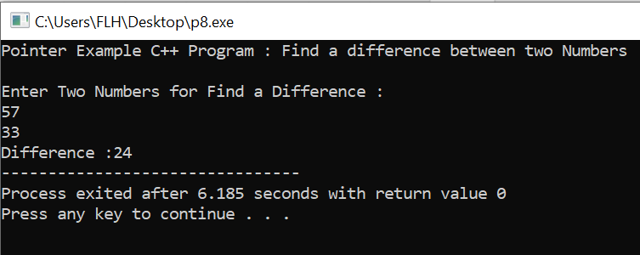

**Q9: Simple Program for Print String Using Pointer in C++**

#include <iostream>

#include<conio.h>

using namespace std;

int main() {

// Declare Variables

char str[20], *pt;

cout << "Pointer Example C++ Program : Print String \n";

cout << "Enter Any string [below 20 chars] : ";

cin>>str;

// Assign to Pointer Variable

pt = str;

while (*pt != '\0') {

cout << *pt;

pt++;

}

getch();

return 0;

}

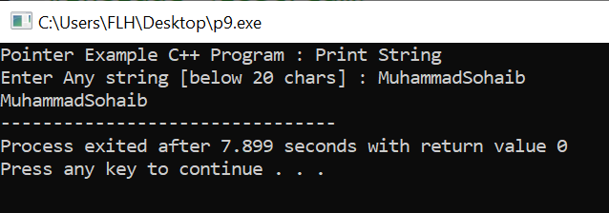

**Q10: Simple Program for Count vowels String Using Pointer in C++**

#include <iostream>

#include<conio.h>

using namespace std;

int main() {

// Declare Variables

char str[20], *pt;

int i = 0, c = 0;

cout << "Pointer Example C++ Program : Count vowels String \n";

cout << "Enter Any string (small letters) [below 20 chars] : ";

cin>>str;

// Assign to Pointer Variable

pt = str;

while (*pt != '\0') {

if (*pt == 'a' || *pt == 'e' || *pt == 'i' || *pt == 'o' || *pt == 'u')

c++;

i++;

pt++;

}

cout << "\nLength of String : " << i;

cout << "\nVowels Count In the String : " << c;

cout << "\nConstant Count in the String : " << (i - c);

getch();

return 0;

}

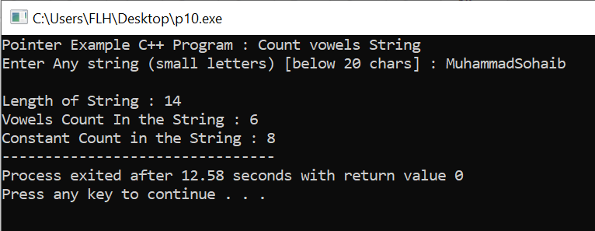

**Q11: Pointer to Pointer or Double Pointer Example Program In C++**

#include <iostream>

#include<conio.h>

using namespace std;

int main() {

int var;

//Pointer Variable Declaration for Integer Data Type

int *pt;

//Double Pointer Variable Declaration with Double Dereference operator (**)

int **dp;

cout << "Pointer Example C++ Program : Pointer to Pointer or Double Pointer \n";

var = 100;

cout << "Address of var [&var ] :" << &var << "\n";

cout << "Value of var [var ] :" << var << "\n\n";

//& takes the address of var , Here now pt == &var, so *pt == var

pt = &var;

cout << "Address of Pointer [pt ] :" << pt << "\n";

cout << "Value of Pointer [*pt ] :" << *pt << "\n\n";

//& takes the address of pt , Here now dp == &pt, so *pt == pt and **dp==var

dp = &pt;

cout << "Address of Double Pointer [dp ] :" << dp << "\n";

cout << "Value of Double Pointer [*dp ] :" << *dp << "\n\n";

cout << "Double Pointer Value [**dp] :" << **dp << "\n";

getch();

return 0;

}

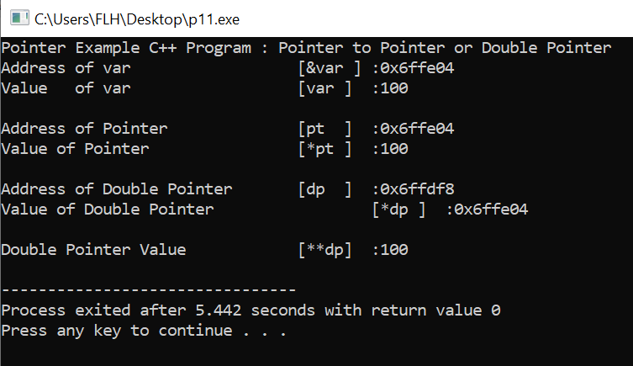

**Q12: Simple Program for Pointer and Array Example in C++**

#include <iostream>

#include<conio.h>

using namespace std;

#define MAX_SIZE 5

int main() {

// Declare Variables

int var[] = {10, 20, 30, 40, 50};

int i = 0;

//Pointer Variable Declaration for Integer Data Type

int *pt;

cout << "Pointer Example C++ Program : Pointer and Array \n";

//& takes the address of var , Here now pt == &var, so *pt == var

pt = &var[0];

while (i < MAX_SIZE) {

cout << "Position : " << i << " # Actual : Value : " << var[i] << " , Address = " << &var[i] << " \n";

cout << "Position : " << i << " # Pointer : Value : " << *pt << " , Address = " << pt << " \n\n";

i++;

// pt++ is increasing Address value based on Data Type

pt++;

}

getch();

return 0;

}

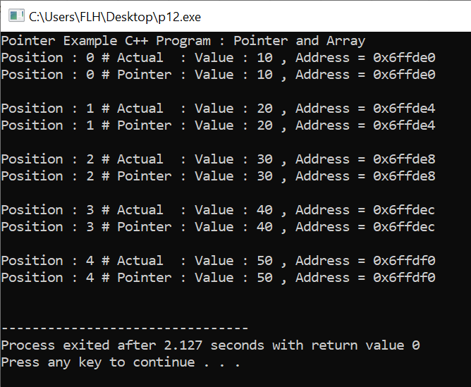

**Q13: Simple Program for Sum of Integer an array using pointers in C++**

#include <iostream>

#include<conio.h>

using namespace std;

#define MAX_SIZE 5

int main() {

// Declare Variables

int var[] = {10, 20, 30, 40, 50};

int i = 0, sum = 0;

//Pointer Variable Declaration for Integer Data Type

int *pt;

cout << "Pointer Example C++ Program : Sum of Integer Pointer and Array \n";

//& takes the address of var , Here now pt == &var, so *pt == var

pt = &var[0];

while (i < MAX_SIZE) {

i++;

// Calculate sum using pointer

sum = sum + *pt;

// pt++ is increasing Address value based on Data Type

pt++;

}

cout << "Sum of Array : " << sum;

getch();

return 0;

}

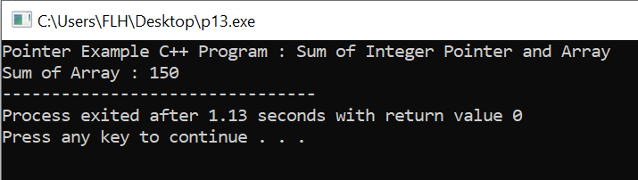

**Q14: Simple Example Program for Passing pointers to functions In C++**

#include <iostream>

#include<conio.h>

using namespace std;

// Declare Add Numbers Function Using Pointer

void add_numbers(int *value1, int *value2, int *result) {

*result = *value1 + *value2;

}

int main() {

// Declare Variables

int number1, number2, result = 0;

cout << "Pointer Example C++ Program : Passing pointers to functions In C++ \n";

// Read User Input

cout << "Enter value of Number # 1: ";

cin>>number1;

cout << "Enter value of Number # 2: ";

cin>>number2;

//Print Values Pass to Reference

cout << "Before Pass to Reference : Number # 1=" << number1 << ", Number # 2=" << number2 << ", Result # :" << result << " \n";

//Call add_numbers Function By Passing Reference

add_numbers(&number1, &number2, &result);

//Print Values Pass to Reference

cout << "After Pass to Reference : Number # 1=" << number1 << ", Number # 2=" << number2 << ", Result # :" << result << "\n";

getch();

return 0;

}

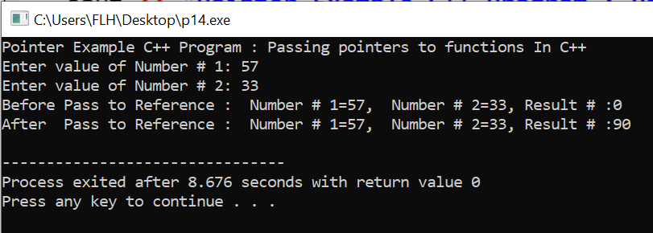

**Q15: Simple Example Program for Area Of Circle Using Pointer In C++**

#include <iostream>

#include<conio.h>

using namespace std;

// Declare Area of Circle Function Using Pointer

void area_of_circle(float *value, float *result) {

*result = 3.14 * (*value) * (*value);

}

int main() {

float radius, area;

cout << "Pointer Example C++ Program : Area Of Circle Using Pointer and Functions\n";

cout << "\nEnter the radius of Circle : ";

cin>>radius;

//area = 3.14 * radius * radius;

area_of_circle(&radius, &area);

cout << "\nArea of Circle : " << area;

getch();

return 0;

}

